Digital Portfolio Assessment
Types of portfolios and the tools to create one and why do it.

School Technology Management
EME 6425
Dr. Susan Zucker

The Dynamic Duo Duo
Mary Jo Coyle-Hilles
Linda Morris-Henry
Christina Smith
Suzanne Wilkerson

TABLE OF CONTENTS

Digital Portfolios 3
Purposes of ePortfolios 4 Types of ePortfolios 4
ePortfolio Tools 6
ePortfolio Assessments 9
Examples of creating ePortfolios
Suzanne Wilkerson-Elementary ePortfolio 9
Linda Morris-Henry-High School ePortfolio 9
Christina Smith-High School ePortfolio 10
Mary Jo Coyle-Hilles-Facts.org ePortolio 11
Christina Smith-Beyond High School ePortfolio 11
Creating ePortfolios
Using Word 12
Using PowerPoint 13
References 14

Digital Portfolios
Back to Table of Contents

There are so many reasons to create a Digital Portfolio. The picture below might demonstrate why a portfolio promotes a deep learning for all ages. It provides students with the motivation to integrate technology into their learning and demonstrate many skills across the curriculum including technology.

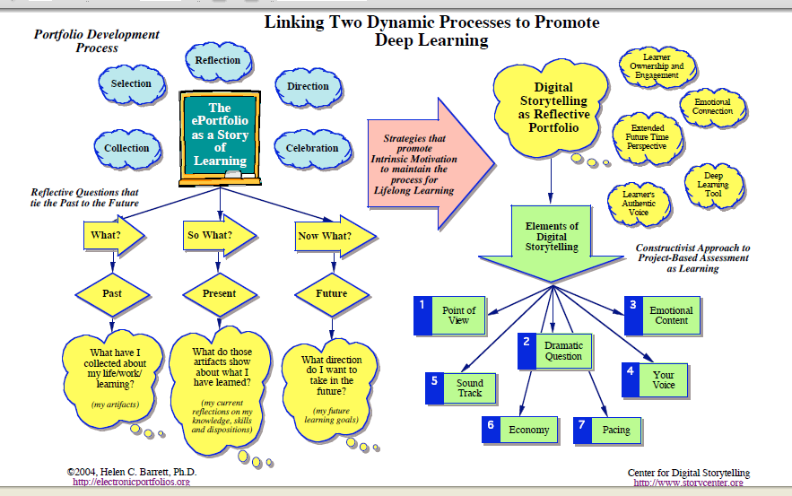
http://electronicportfolios.com/digistory/ePortfolioStory.pdf

“The journey unfolds when teachers decide to move away from traditional teaching and toward a new vision of instructional design. It’s a learning journey—for teacher and student alike. The journey focuses on learning, not the technology. Taking the journey is critical in preparing students to live, learn, and work in a technology-rich world.” (ISTE Educators Resources)

The National Education Technology Standards and Benchmarks are woven into Electronic Portfolios and promotes the integration of technology across the curriculum. They include:
- Basic operations and concepts
2) Social, ethical, and human issues
3) Technology productivity tools
4) Technology communications tools
5) Technology research tools

CES (Coalition of Essential Schools) National Web, state there are 5 goals to creating a portfolio.
- To help students become more reflective about themselves as learners
- To demonstrate evidence of student growth and achievement
- To inform instruction, influence practice, and set goals
- To extend children's learning
- To support and explain the grading system
Purposes of ePortfolios
Back to Table of Contents
Why might you use a portfolio assignment? Portfolios typically are created for one of the following three purposes: to show growth, to showcase current abilities, and to evaluate cumulative achievement. Some examples of such purposes include
1. Growth Portfolios
a. to show growth or change over time
b. to help develop process skills such as self-evaluation and goal-setting
c. to identify strengths and weaknesses
d. to track the development of one more products/performances
2. Showcase Portfolios
a. to showcase end-of-year/semester accomplishments
b. to prepare a sample of best work for employment or college admission
c. to showcase student perceptions of favorite, best or most important work
d. to communicate a student's current aptitudes to future teachers
3. Evaluation Portfolios
a. to document achievement for grading purposes
b. to document progress towards standards
c. to place students appropriately

Types of ePortfolios
Back to Table of Contents

Elementary, K-Second Grade, examples
- A table of contents
- K - a self-portrait; 1st and 2nd grades - a Dear Reader letter
- A student selected "Special Choice" of work which may not be covered in the academic sections - this may include photographs of 3-dimensional work, drawings, videos, etc.
- Four writing samples that demonstrate process to product. Rough drafts must be included. Two selections need to be made from work done September-January and two need to be made from work done January-June. Each piece will have an entry slip with an explanation of why the work was chosen. Kindergarten will choose from their journal entries and reflections.
- Math/Science Sample - apiece of work that shows student's reasoning and problem solving skills. This could come from journal entries, experiment booklets, worksheets, etc.
Elementary, K- Third to Fifth Grade, examples:
- A table of contents
- A Dear Reader letter that reflects something about the student's personal perspective on his or her work
- A special "student selected" piece not covered in the academic selections.
- Four writing samples that demonstrate process to product. Rough drafts must be included. Two selections need to be made from work done September-January and two need to be made from work done January-June. All pieces must have entry slips and reflections.
- Reading - Student chooses a favorite story from teacher assigned readings and tells why she/he liked the story, and one personal favorite story and tells why she/he liked it.
- Math/Science Problem Solving: one piece of work that shows student's reasoning and problem solving skills with communication about the work.

Middle School

Transitional Portfolios located at http://www.dcn-cde.ca.gov/portfolios.htm
Artifacts, a collection of students work and use current technology.
Explore Careers
- Career Development
- Career Planning - Florida CHOICES
- Career Clusters & Major Areas of Interest
Plan Ahead
- Academic planning with ePEP
- Major Area of Interest Search
- Things to Do, Year-by-Year
High School
Senior Exit Portfolio
- cover letter
- sample of work
- reflection on process of creating sample of work
- reflection on growth
- teacher or peer comments
- description of knowledge/skills work indicates
Transitional Portfolios located at http://www.dcn-cde.ca.gov/portfolios.htm
FACTS.org on-line Portfolio
- Graduation Requirements
- Earning College Credit Now
- Bright Futures Scholarships
- FCAT & College Entrance Tests
- State University Admission Requirements
Plan Ahead
- Academic planning with ePEP
- Major Area of Interest Search
- Things to Do, Year-by-Year

Artifacts, a collection of students work and use current technology.
Record your experiences and skills, store resumes, examples of work, maintain a list of academic and work references.

College
Artifacts, a collection of student work and use current technology.
FACTS.org on-line Portfolio
Record your experiences and skills, store resumes, examples of work, maintain a list of academic and work references.

Professional

Artifacts, a collect of Professional Accomplishments and to demonstrate skills abilities related to their profession and use of current technology.
FACTS.org on-line Portfolio
Record your experiences and skills, store resumes, examples of work, maintain a list of academic and work references.

ePortfolio Tools
Back to Table of Contents

Authoring Tools that would be most commonly used and mostly understood for Digital Portfolios would be Microsoft Office Word, PowerPoint, FrontPage, and PDF’s. Any type of work saved on your computer becomes digital. How you present your ePortfolio is up to you. Depending on your purpose you may keep your Digital Portfolio on your computer, thumb drive, CD, or on-line.

The best Digital Portfolio for Elementary students would be for teachers to keep their work on a computer in separate folders or create a teacher ePortfolio web site to document student’s work. If you choose to use your computer you must choose the software program that you have available at the time and create hyperlinks between documents to create a flowing user friendly ePortfolio. We will show you how in the next sections on Creating an ePortfolio.

On-line Portfolio’s offer the most options and can depend on whether you want to pay for own paid or unpaid we space. If you create your own you will need a web page editor to create an on-line document. If you use an on-line service they will provide you will the necessary tools to create an on-line ePortfolio.

Through research, the best free on-line ePortfolio offered to students and professionals is FACTS.org. All Middle School or High School should be used as part of them selecting their majors and keeping up on relevant work and credits for completing high school or college. Students can record your experiences and skills, store resumes, examples of work, maintain a list of academic and work references. You can build up to 3 portfolios, customizing them for different referred users like potential employers or graduate schools. Throughout your college career and afterwards, you can modify your portfolio to ensure it shows you at your best. You can locate facts.org at http://facts23.facts.org/navigation/home.do

Through research, the best free on-line elementary ePorfolio would be http://www.thinkquest.org/en/
“A nonprofit organization funded by Oracle, the foundation delivers ThinkQuest – a widely acclaimed education technology program – to K-12 schools globally. ThinkQuest is a protected, online learning platform that enables teachers to integrate learning projects into their classroom curriculum and students to develop critical 21st century skills. For more information, visit http://oraclefoundation.org.” Teachers and students can create e-portfolios through projects and even enter contests. It is very interactive and would work especially well with elementary students and teachers.

Other computer digital tools would be:
Authoring Tools- These are tools that can be used to author portfolios (offline), but require web server space to publish online. Portfolios created with these tools can also be published on CD-R or DVD-R. No interactivity*

Apple's iWeb, Dreamweaver, FrontPage, nVu, or any web authoring tool
Microsoft Office & Open Office: Word, Powerpoint & Lecshare Pro
Adobe Acrobat
MovieMaker2, PhotoStory3, iMovie, or any video editing tool

Other on-line tools would be:

INDIVIDUAL & INSTITUTIONAL
Static Web Services- These are static web services that an individual or institution may use to create and publish a presentation portfolio - little or no interactivity* (Web 1.0)

GeoCities
eFolio Minnesota
Tripod
Digication
KEEP Toolkit
GooglePages

Interactive Web Services- These are dynamic web services that an individual or institution may use to create and publish a presentation portfolio AND allows interactivity* (Web 2.0)

WordPress (blog)
WikiSpaces
PB Wiki
GoogleDocs - Document and Presentation
ZOHO Writer
EduSpaces (Elgg)

INSTITUTIONAL

Software - Server required- These are systems that an institution would install on their own server to provide space for hosting portfolios. Interactivity* but NO data management system** Many institutions include access for students to create ePortfolios.

Userland's Manila
Blackboard
(old: Content System and new: Vista/CE)
Elgg, Mahara, OSPI, ePEARL
Embedded in Moodle: Moofolio, MyStuff (U.K.)
Open Source Content Management Systems: Plone, Drupal
Microsoft SharePoint

Hosted Services- These are systems that an institution adopts (no server required) that host portfolios. Usually supports interactivity* but NO data management** or reporting systems

MyEport (Maricopa)
Think.com (K12 school accounts only)
nuVentive's iWebfolio
PebblePad (U.K.)
Pupil Pages (K12)
Epsilen
My eCoach

Assessment Systems - Hosted Services-There are hosted systems that an institution would adopt (no server required) that will allow hosting portfolios, facilitates interactivity, and includes a data management** and reporting system for assessment

TaskStream
College LiveText
Chalk & Wire
FolioTek
nuVentive's TracDat
Richer Picture

Hosted Services- are paid hosting services that require knowledge of web pages editor and you upload the files yourself. You will have total access to creating and editing ePortfolios. The following companies are user friendly and you upload your files like you would on any computer. The services can cost anywhere from $4.95 a month and up and a paid domain name from $8.95 a year and up.
www.godaddy.com
www.angelfire.com

To view Christina Smith’s ePortfolio click on http://www.christinalouisesmith.com/Portfolio/Smith.html purchased through www.godaddy.com

To view a political ePortfolio click on http://www.voteforbobhastings.com/ purchased through www.angelfire.com

ePortfolio Assessments
Back to Table of Contents

“Portfolios provide an excellent vehicle for consideration of process and the development of related skills. So, portfolios are frequently included with other types of authentic assessments because they move away from telling a student's story though test scores and, instead, focus on a meaningful collection of student performance and meaningful reflection and evaluation of that work.” (Jon Mueller, 2008)

Elementary ePortfolio-Suzanne Wilkerson
Back to Table of Contents

Suzanne Wilkerson is an Elementary teacher at Suncoast Elementary School in Spring Hill, Florida, Hernando County.

Electronic Portfolios can be utilized in many ways at the elementary school level. There are commercial programs designed to organize and store electronic portfolios. The site below shows some samples of how a teacher can keep track of a student’s progress in the areas of reading, writing, math, social development, and conference reports. Let’s take a look at Colleen’s portfolio, and elementary student.

Here is the link: http://www.richerpicture.com/samples.php#elementary.

The same thing can be accomplished using Microsoft PowerPoint. Documents, recordings, videos, written text, and digital pictures, all can be stored on a slide in PowerPoint. As each year begins a new slide can be added to separate the year from the previous year. Each student should be assigned a unique login, like their student ID #, and their data can be stored on the school network server. Students or teachers can add samples of projects, recordings of the student reading, scanned writings, art projects, etc., in their folder starting in Kindergarten up to 5th grade. At any time, a teacher can access the digital portfolio, which would be very useful for a parent conference. At the end of 5th grades, the student portfolio can be copied onto a CD for the student to take with them, a great keepsake of their elementary years.

High School ePortfolio-Linda Morris-Henry
Back to Table of Contents

Linda Morris-Henry teaches Business Education courses at Deland High School in Volusia County.

In my class, Computer for College and Career (CCC), a requirement of the program is that I teach the students how to organize their high school portfolio. At my high school a requirement for graduation is that students prepare a portfolio that has a sample of their work through out high school as well as a resume and cover letter.

- Freshman year students are taught the basic keyboarding skills.
- Sophomore year – students are taught how to research, write and orally present a research paper.
- Junior year – students are taught how to write a resume, cover letter and fill out an application (hard copy and online)
- Senior year students organize their portfolio for submission

All the work done in the CCC class is saved to a folder named Portfolio on their flash drives. Additionally, the CCC class students are taught the basics of Excel, Access and PowerPoint.

Organizing Portfolios –
- 3” binder
- Approximately 12 index tabs for each subject such as:
-Resume, Cover Letter
-Math
-English
-Computer Classes
-Science Classes
- Economics
-Elective Classes
- Volunteer Hours
CCC students are required to maintain a 3" binder for this class. It is divided up using index by the following tabs: Microtype, MS Word, MS Excel, MS Access, MS PowerPoint, Text/Quix, Extra Credit and Notes.

All work done and graded is kept in the folder.
10% of the student's grade is for maintaining folder/portfolio.
At the end of the school year student leave class with all samples of work in folder
In addition, students create individual folders on their flash driver for Word,
Excel, Access and PowerPoint and they transfer work to this folder.

High School ePortfolio-Christina Smith
Back to Table of Contents

Christina Smith is a Business Education Teacher at Chiefland High School in Levy County. Her CCC, Business and Graphic Design students maintain a Portfolio that is then turned into an ePortfolio. The portfolio will not be hosted on any server, but maintained in a computer form by the students. Students start by created a PowerPoint notebook in the first year of CCC, in Digital Design 1 they attach their PowerPoint notes to a web page created ePortfolio, by the third year students have learned how to document such artifacts needed in a portfolio and how to present them through a rubric that she provides. The following is the link to the ePortfolio assignment for Christina Smith’s Digital Design 2 class, http://www.levy.k12.fl.us/schools/chs/FacultyandStaff/SmithC/DigitalDesign2/index.htm
Portfolios are created as a progression of each program.

FACTS.org ePortfolio-Mary Jo Coyle-Hilles
Back to Table of Contents

Mary Jo Coyle-Hilles is a Guidance counselor at F.W. Springstead High School in Spring Hill, Florida, Hernando County. She maintains student do e-peps in Middle School, declare majors, and create an ePorfolio on-line at FACTS.org.

Florida’s Academic Counseling and Tracking for Students known as FACTS.org is a comprehensive program for Florida students from middle school through graduate school.
FACTS.org is used by students, parents, counselors, teachers and advisors to answer questions concerning education and career opportunities in Florida and beyond. Students, teachers, and counselors are allowed to access the site and use many of the tools without opening an account. To set up or access individual accounts, a password must be obtained. Teachers may enter the site by clicking on the box entitled “Counselors and Educators”. One of the most valuable tools is the “Counseling for Future Education Handbook” listed under “Advising Manuals”. This handbook used by counselors is also a valuable tool for teachers and parents. You will find everything you need to know about high school graduation requirements, college requirements and technical and vocational school requirements. Parents can access information about college tuition and Bright Futures requirements and sources for financial aid. An excellent means of getting to know this handbook is to scroll down to page 2 of the handbook and review the table of contents. One of the tools related to today’s presentation is the development of College Portfolios which can be developed beginning in high school. To access this tool click on “College Students” then go to the box “Portfolios”. Go to “Sample Portfolios” to get an idea of the tools within this “toolbox”.

Beyond High School Portfolio-Christina Smith
Back to Table of Contents

Professional ePortfolio are a must in pursuing your future career goals as an educator, administrator, or in advanced careers to demonstrate your accomplishments and future goals. The following link is to her professional ePortfolio located at www.christinalouisesmith.com

Creating an ePortfolio
Back to Table of Contents

Using Microsoft Office Word

Create a cover page in word, just as child’s name, grade and teacher. Include a Table of Contents for the documents that you are presenting in each child’s portfolio. Save the child’s information in a separate folder on a computer, usually last name first initial.doc Create each document representing what you are including. Once you have created your documents you can create hyperlinks as you would when creating web pages. Open your table of contents word document, highlight the text you want to hyperlink, click INSERT HYPERLINK, locate your file you wish to hyperlink and click ok.

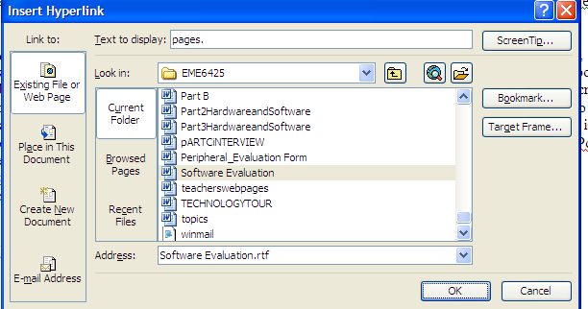

Once you have hyperlinked all your documents and re-save your table of contents, you will only have to open the table of contents click on the links and all your other documents will open.

You can also create the whole document in one word file, just create a bookmark on each heading (Click Insert, Bookmark, name your bookmark with no spaces), then link to Place in The Document. This is demonstrated using this document with the ePortfolios table of contents.
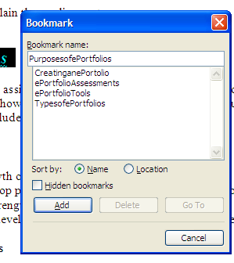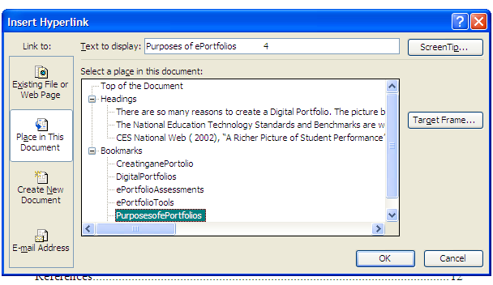

Using Microsoft Office PowerPoint

PowerPoint uses the same basic concept of hyper linking, except you only need one PowerPoint Presentation.
You can hyperlink to other slides and create a back button to hyperlink back to your table of contents. On the first slide include the child’s name, grade and teacher. The second slide creates a table of contents for what you going to contain in your PowerPoint. Once all your slides are create with the correct documentation, and then you go back to your table of contents slide and hyperlink them.

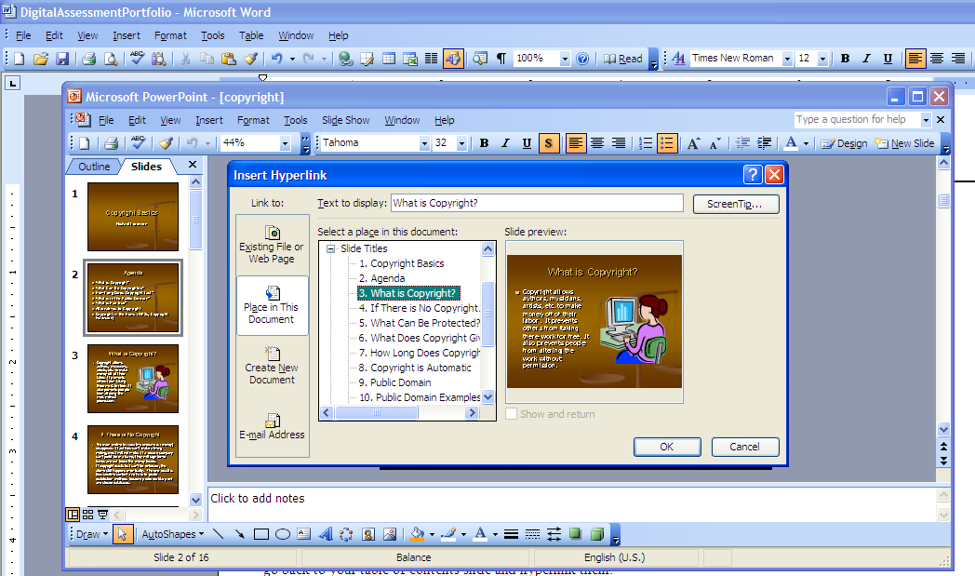
Making sure you click on Place in The Document and click the slide you want to hyperlink it to, and then click OK.
I recommend that you create one button on the second slide and link it to the table of contents, after that you should be able to just copy and paste that on the slides after that. You with then always create a back hyperlink button. This is an awesome way to use PowerPoint.

There are many more tools to create ePortfolios we just listed the ones that most are familiar with.

REFERENCES

Barrett, Helen C., Ph.D (2004), “Picture of Electronic Portfolios”,
http://electronicportfolios.com/digistory/ePortfolioStory.pdf Retrieved 14 September 2008

Barrett, Helen C., Ph.D. (2008), “Categories of E-Portfolio Tools”, http://electronicportfolios.com/categories.html , Retrieved 14 September 2008

CES National Web (2002), “A Richer Picture of Student Performance”, Digital Portfolio, Chapter 3
http://www.essentialschools.org/pub/ces_docs/resources/dp/cet.html Retrieved 14 September 2008

California Department of Education (1997), “Middle School and High School Transitional Portfolios and Guides”, http://www.dcn-cde.ca.gov/portfolios.htm Retrieved 14 September 2008

FACTS.org (2008), “Career Portfolios”, http://facts23.facts.org/portfolio/index.jsp?pageId=060501 Retrieved 14 September 2008

ISTE Educators Resources, (2007), “Your Learning Journey”
http://www.iste.org/AM/Template.cfm?Section=Educator_Resources&Template=/TaggedPage/TaggedPageDisplay.cfm&TPLID=22&ContentID=966, Retrieved 14 September 2008

Mueller, Jon (2008) “Authentic Assessment Toolbox”
http://jonathan.mueller.faculty.noctrl.edu/toolbox/portfolios.htm Retrieved 1 September 2008

Richer Picture. (2008). A digital picture of student achievement. http://www.richerpicture.com/samples.php#elementary

Smith, Christina (2008), “Digital Design 2-Unit 2-Ms. Christina Smith”,
http://www.levy.k12.fl.us/schools/chs/FacultyandStaff/SmithC/DigitalDesign2/index.htm

Smith, Christina (2008), “Vote for Bob Hastings” http://www.voteforbobhastings.com

Back to Table of Contents

