RUNNING HEAD: Second Chance Adult Programs

Second Chance Adult Training and Employment Programs

Christina L. Smith

University of South Florida

Dr. Victor Hernandez

July 25, 2010

Second Chance Programs of Adult Education

“Zweiten Buldungsweg”

Abstract

The advancement of new technologies has created new jobs that require new skills. The demands of those new skills promote an increase for programs that provide training of new skills to meet those demands. Second chance adult training and employment programs provide individuals with an opportunity to gain those needed skills. The purpose of this paper is to explore comparable adult second chance training and employment programs between the United States and Germany. As contributors of each society they desire to promote a skilled workforce that will generate a more globally competitive economy that will meet the demands of each labor market.

Introduction

There are two educational systems in the United States and in Germany today. They are the “first-chance” educational system of compulsory education and the “second-chance” system of adult education and training programs. The main attendees to the “second-chance” systems are individuals who have not completed the “first chance” system as result of individuals dropping out of compulsory school. School drop outs include those that are economically disadvantaged, pregnant, incarcerated, addicted to drugs, disabled, or just not motivated intrinsically. A study done by the OECD in 2007 recorded the United States dropout rate at 28% and Germany dropout rate at 8%.[1]

The demands of jobs in the labor market nationally and globally are jobs that include qualified applicants with the completion of compulsory education or higher levels of learning. The future demands of jobs include biomedical engineers, financial examiners, medical scientist and physicians that require an advanced degree. Those jobs that require additional training without a higher degree include home health aides, physical therapist aides, medical assistants, and dental assistants.[2] Each job is unique and the type of job and educational training will depend on each individual’s income level. The term education pays shows that a higher level degree pays more than someone that has no high school diploma.[3]

The most effective way to create a better-skilled workforce would be to enhance the programs that are more explicitly oriented toward those less educated or those that need to rebuild new skills. “America’s young people will always be struggling to catch up through the second-chance system if the first isn't good enough, and if the first is good enough, the second might not be needed as much.” [4]

Background

Second chance programs are designed to assist an individual with an opportunity to gain or re-gain skills that meet the current workplace demands. The mission is to provide individuals the ability to be self-sufficient in today’s society. The rationale behind second chance adult training and employment programs is that with the world’s changing economy it makes it difficult for many people with personal barriers to become employed or even re-employed. These personal barriers are comparative to the United States and Germany as those personal barriers are but not limited to low basic skills, limited work experience, health problems, disabilities, veterans, age, unemployment, high school drop outs, released incarcerated youths and limited incomes. These barriers target the young, elderly and through all cultures alike. It generally affects low income individuals, but can also affect someone who just lost everything in our current economic depression.[5] The current trend for the United States and Germany is to increase workforce skills in a competitive global economy.

“In a time of continuous economic, social and technological change, skills and knowledge become quickly out-of-date. People who have not been able to benefit from formal education and training must be given opportunities to acquire new skills and knowledge that will give them a second chance in life and at work”. [6]

Purpose

The purpose of this research will compare the United States and Germany’s “second chance” adult training and employment programs available for individuals that want to increase their employability skills either by obtaining educational requirements or learning new skills. The “second chance” programs provide the United Nations Educational, Scientific, and Cultural Organization (UNESCO) international model of “Education for All” as success for every individual to be a productive viable citizen in a in a global competitive world.[7]

Research Question

1. What are the United States and Germany comparable “second chance” adult training and employment programs that provide individuals with the qualifications and skills to fill the demands of the labor market?

Significance

The United States second chance programs are numerous therefore the significance of this research will be to research Germany’s comparable second chance adult training and employment programs that are successful. The United States workforce is not prepared for competing in the economy. The data is reflected in the many studies that have observed and surveyed workplace readiness.  In the study done by the Conference Board in 2008 surveyed businesses that resulted in necessary basic skills, critical thinking skills, ethics, and social training was needed for those entering the workforce. The same skills were recognized in a *Nation at Risk* when it was written in 1985. The study presented by Statistics Canada and Organization for Economic Cooperation and Development (OECD) shows data from a study done through the Program for International Student Assessment (PISA) to include national assessment of 15 year-olds in reading, mathematics, and science literacy.  The data was obtained in 2003 from over 42 participating countries.  They define their scope to document that “Literacy skills have a significant impact on economic success.” [8] The data for reading literacy skills showed that the United States ranked 16th and Germany ranked 22nd in the World.  The data for mathematic literacy skills showed that the United States ranked 20th and Germany ranked 21st in the World. The data for science literacy skills showed that the United States ranked 15th and Germany ranked 21st in the World. The skills that need improvement are the same skills needed to sustain a viable and productive workforce. In the study called “Employers’ Perspectives on the Basic Knowledge and Applied Skills of New Entrants to the 21st Century U.S. Workforce”  showed  that basic skills had improved with additional educational training as seen in Appendix A. [9] Skills that are important in the United States and for the growth of our economy.

As unemployment and poverty reaches an all time high for both the United States and in Germany, as well as the projection of the future of higher level skills needed to fill the demand of the labor market the more important second chance adult training and employment programs become for those that are able to work. It is important as now is the time to train and re-train those with new skills so that they unemployed will be able to fill positions when they become available. This will allow filling positions with skilled people in jobs that would not necessarily have filled before training. Therefore by providing second chance adult training and employment programs that should meet the supply before the demand exists.

Current Trends

Comparative educational systems have created a problem that does not provide each society with the literacy to have the basic skills for today’s workforce and for today’s technologies. Many young students leave schools with the necessary basic literacy or work skills to succeed in the workplace or in postsecondary education. “Only 68 out of every 100 ninth graders will complete high school on time”.[10] The only way to increase wages and advance careers will be to acquire the skills necessary to acquire the work and technical skills that qualify them for advancements and higher levels of education. “It is emerging as one of the nation’s major challenges in the decades ahead”.[11]

The challenges are budgetary and the need to increase programs that provide adults a second chance to become self-sufficient. The challenges will be in years ahead, as more people need these programs and the funds for each program are continually limited or decreased. As a result of poverty, unemployment and the demand for skills in the workforce increase so will the demand for second chance programs supported by federal funding.

The diffusion of technology innovations have created new workplace skills that emphasize more technical, problem-solving skills and competencies that incorporate the use of basic foundational workplace literacy skills. As technology and demographics change the global labor market requires a new skilled workforce that demands higher skilled workers. If an individual does not have the basic workplace skills of reading, writing and mathematics an individual will be unqualified to work, let alone work in higher skilled paying jobs, leaving them only with low-wage options.[12] The study by Achieve, Inc. (2004) found that 60% of employers say students that graduate lack basic skills in grammar, spelling, writing and basic math. The increased demands of basic workplace literacy skills are necessary for our youth to fill highly skilled jobs.

Second Chance Adult Training and Employment Programs Comparison

The growth in second chance training and employment programs are derived to close the gap in workplace skills. The researcher analyzed over 37 U.S. programs and determined that a comparable study in second chance adult training and employment programs would benefit an individual the most if they were at a disadvantage economically.

For the purpose of this paper adult education refers to those who have not completed compulsory school. The adult education target population are those considered 16 years or older lacking the basic literacy skills because of learning disabilities or because they dropped out of school. They are the necessary skills that provide individuals with the ability of employment and educational opportunities.

In the United States data was collected by the U.S. Census in 2006 and documented that 26.25 percent of the target population never completed school with a high school diploma.[13] In 2004-2005 the National Reporting System for Adult Education recorded Florida for one-third of the participation rate of the least illiterate enrollment. It also recorded that Florida had 13 percent participating at the lowest level of literacy.[14]

In the United States those that drop out of school can obtain a General Equivalency Diploma (GED). Candidates for the GED program must be at least 18 years old. Exemptions can apply if a candidate is at least 16 years of age and has been granted an age waiver by their local school board. The GED allows individuals to qualify for more jobs and opportunities.

The GED tests reading, writing, social studies, science, and mathematics. The cost of the GED for an individual is $75.00 and is to be paid prior to taking the GED. The test does not require you to attend adult education classes in preparation to take the GED, but they are available if an individual chooses. If the individual chooses to take the GED preparation, students can apply through their local community college for classes that are free to those who qualify or they can pay for books or lessons through independent learning online. [15] Classes are available during the day or evening and it is up to the individual how long they need to learn the topics that are to be tested. Once a GED has been awarded the individual is eligible for further educational opportunities that are available through any community college, university or vocational school.

The GED has become widely available and continues to grow to help individuals meet the educational goals established by the federal government helping individuals succeed. Evaluation findings included high school diploma or GED from 2001 to 2007 grew 26 percent (Expectmore.gov, 2010). The programs in 2004 found the cost of $3,081 were the lowest cost per individual as compared to other training programs (Expectmore.gov, 2010). The analysis of the data shows that the assessment recorded by Expectmore.gov evaluated the Adult Education State Grants as excellent.

A high school diploma or GED is required prior to applying to a community college, university or vocational school. Additional admission requirements can include a College Placement Test (CPT), Test of Adult Basic Education (TABE), and/or Scholastic Aptitude Test (SAT) scores. The test scores allow for placement in the courses chosen for the program enrolled in. In the United States Office of Program Policy Analysis and Government Accountability (OPPAGA) assessed that over 55% of students entering college needed remediation in mathematics, reading, and/or writing. [16] Another example of where individuals lack basic literacy skills. Students then must apply for Federal Student Aid (FASFA) for financial assistance. Federal Aid is paid through the Federal Program Pell Grant, which constitutes one of the most funded programs under the Department of Education and is available to those with low incomes for undergraduate studies.[17] See the funding of second chance training and educational programs in Appendix B. The courses associated with remediation due to lack of basic literacy skills are unpaid by any financial aid, per personal communication with Central Florida College.[18] It becomes another financial burden that individuals have to bear and are unable to because they have little to no income. The OPPAGA study in 2009 assessed that only 52% of the 55% needing remediation completed the program enrolled in.[19] The financial burden and lack of basic literacy skills continues to make it difficult for those individuals in need of a second chance to get a head in adult education after they receive their GED in the United States.

In Germany’s compulsory educational system one must have a certificate of completion or an arbitur from one of the four compulsory educational system sectors; which include Hauptschule and Realschule, which individuals receive a leaving certificate and a Gesamtschule and Gymansium, which individuals receive an arbitur. An arbitur is necessary if an individual is to attend a university. Students in Germany who drop out of school have similar barriers to those individuals in the United States.

The Federal Statistics Office in Germany (2007) recorded that there were 867,000 individuals who did not have an equivalent school leaving certificate or an apprenticeship. The percentage of 14-18 year olds decreased from 14.9% to 12.9% between 1999 and 2007.[20] The adult education programs established in Germany require individuals who want more employment or educational opportunities to attend a Second Chance Education School that is located in each Länder or State within Germany. The schools are under the authority of each Lander. The Second Chance Education Schools were established to prepare adults that are returning to school to acquire school diplomas, further employment and educational opportunities. The Second Chance Programs for adult education are funded under the European Socrates-Grundtvig Programme.[21] The Second Chance Education Schools accept those who are seeking a general school advanced certificate (must be a minimum of 17 years old), a middle school secondary school certificate (must be a minimum of 18 years old), a technical college, or a general university entrance qualification of an Abitur (must be a minimum of 19 years old). [Allgemeine Hochschulreife (Abitur):](http://translate.googleusercontent.com/translate_c?hl=en&ie=UTF-8&sl=de&tl=en&u=http://www.arbeitsagentur.de/nn_442852/zentraler-Content/A02-Berufsorientierung/A022-Infomedien/durchstarten/Bremen.html&prev=_t&rurl=translate.google.com&twu=1&usg=ALkJrhjNAbKYNeTBv0OSG2FLFMCF4b3I4w#d1.4)Classes are held during the day or in the evening. The programs can take up to 1 to 2 years to complete with a final exam in each program.[22] In the city of Bremen, the school is known as the Adult School Bremen and was established in 1947, 1000 students are currently enrolled for adult training and educational programs. [23]

In helping those that are less fortunate, individuals can obtain financial aid through the Federal Training Assistance Act (BAföG) to include education loans and scholarships. One in four students receives BaföG support.[24] The amount of full grants awarded has increased in 2007 by 10% to 52.2%.[25] Students receive funding for their cost of living while attending school. Regular school students receive 321 Euros and students in high education receive 398 Euros a month. It doesn’t include the cost of the school unless you are attending a university or a private institution. The cost of a master’s degree of a primary educational teacher was $500.00, Sylvie Frauke (personal communication, 2010). The BaföG is open to all German citizens and individuals that meet the residency requirement. The BaföG is available to help everyone no matter what their circumstances by linking school to work with little financial obligations.

Further research found that students in Germany would obtain a counselor from their local Federal Employment agency, which generally would begin in the 8th grade and contribute to finding employment or an apprenticeship.[26] Once employment is found a contract is made between the individual and the employer as a binding agreement, maintaining that employment last a in Germany. The chances of being terminated are not so quickly advised as they are in the United States.

Conclusion

Second chance adult training and employment programs are very important in providing adults with necessary basic literacy skills, new skills, and higher educational levels of learning as part of the growing economic need for both the United States and Germany. It seems highly cost effective for individuals in Germany to attend second chance education school with the exception of the amount of time it takes to complete. It seems too easy and too quick for one to sit for a GED exam in the United States and believe it is equal to a high school completer that graduated with a high school diploma. Achieve (2004) research on high school exit exams such as the GED reflected 8th and 9th grade material, rather than reflecting the knowledge and skills student needs for college or careers. More than 70% of the students graduating continue to college and more than half need remedial coursework in English and math. If the United States creates an equal system as in Germany’s where the goal is to make sure that those without the education can obtain exactly what they missed through second chance education programs.

The individuals that are provided a “first chance’ and “second chance” education creates the social and educational foundation that makes any individual, community or nation succeed. Although there are many barriers that individuals need to overcome the availability of federal programs have the available resources for an individual to overcome many of those barriers. It is up to the individuals’ self-efficacy to overcome those barriers. The researcher believes that from personal experience that the most common problem of receiving notification of training and employment benefits is the lack of communication. Individuals are uninformed about the many programs and resources that are available.

In conclusion there is a need for second chance employment and training programs to meet the needs consistently and proportionately with the rise in poverty levels and unemployment rates. Only three percent of federal funding in the United States and nine percent in Germany is spent on education with a combined spending on education, training, employment, social services, secondary education and vocational education. [27] The minimum amount of money in the United States is spent on the education of individuals to become self-sufficient. As a result, it is the individuals that are self-sufficient become our most valuable resource to create growth in our economy and advancements globally; therefore it is recommended that the United States must invest more in career and technical education to motivate our youth to stay in school prior to needing a “second chance”.

References

Achieve. Inc. (2004). Ready or not: Creating a high school diploma that counts*.* Retrieved March 30, 2009 from <http://www.achieve.org/files/ADPreport_7.pdf>

Achieve. Inc. (2004). Do graduation tests measure up? A closer look at state high school exitexams. Retrieved March 30, 2009 from <http://www.achieve.org/files/TestGraduation-FinalReport.pdf>

Alliance for Excellent Education. (2009). Understanding high school graduation rates (updated July 2009) Retrieved June 22, 2010, from <http://www.all4ed.org/publication_material/understanding_HSgradrates>

Center on Budget and Policy Priorities. (2008). Policy basic: Where do our federal tax dollars go? Retrieved July 22, 2010 from, <http://www.cbpp.org/cms/index.cfm?fa=view&id=1258>

The Conference Board. (2009). Are They Really Ready To Work? Retrieved June 12, 2010, from <http://www.p21.org/documents/FINAL_REPORT_PDF09-29-06.pdf>

Data360. (2007). [High School Graduation Rates in Select OECD Countries](http://www.data360.org/pub_dp_report.aspx?Data_Plot_Id=120). Retrieved July 10, 2010 from, <http://www.data360.org/pub_dp_report.aspx?Data_Plot_Id=120>

Deutscher bildungs server. (2010). Adult Education as a second chance. Retrieved July 22, 2010 from, <http://www.bildungsserver.de/zeigen_e.html?seite=4479>

Federal Employment Agency. (2010) Breman Second Chance Education Program. Retrieved July 22, 2010 from, <http://translate.googleusercontent.com/translate_c?hl=en&ie=UTF-8&sl=de&tl=en&u=http://www.arbeitsagentur.de/nn_442852/zentraler-Content/A02-Berufsorientierung/A022-Infomedien/durchstarten/Bremen.html&prev=_t&rurl=translate.google.com&twu=1&usg=ALkJrhjNAbKYNeTBv0OSG2FLFMCF4b3I4w>

Federal Employment Agency. (2010). Adult School Bremen for second education. Retrieved July 22, 2010 from, <http://translate.googleusercontent.com/translate_c?hl=en&ie=UTF-8&sl=de&tl=en&u=http://www.erwachsenenschule.de/&prev=_t&rurl=translate.google.com&twu=1&usg=ALkJrhhfcc0LJo5c38OWHsgrzKOXNvdv3w>

Federal Ministry of Education and Research. (2010). Ensuring equal opportunities by means of BaföG. Retrieved July 22, 2010 from, <http://www.bmbf.de/en/892.php>

Federal Statistical Office, Sustainable Development in Germany, Indicator Report 2008

Retrieved July 22, 2010 from, <http://www.destatis.de/jetspeed/portal/cms/Sites/destatis/Internet/EN/Content/Publikationen/SpecializedPublications/EnvironmentEconomicAccounting/Indicators2008,property=file.pdf>

Florida Department of Education. (2010). Application request. Retrieved July 22, 2010 from, <http://www.fldoe.org/workforce/dwdgrants/adulted.asp>

The Florida Legislative. (2007). Half of college students needing remediation drop out. Retrieved July 22, 2010 from, <http://www.oppaga.state.fl.us/Summary.aspx?reportNum=07-31>

MRDC. (2007). Four Strategies to Overcome Barriers to Employment. Retrieved June 15, 2010, from <http://www.mdrc.org/publications/469/overview.html>

National Reporting System for Adult Education. (2006). NRS fast facts. Retrieved July 10, 2010 from <http://www.nrsweb.org/reports/fast_facts.aspx>

Stasz, C. and Chiesa, J. (1998). Education and the new economy: View from a policy planning. Retrieved June 15, 2010, from <http://www.eric.ed.gov/ERICDocs/data/ericdocs2sql/content_storage_01/0000019b/80/15/74/7f.pdf>

UNESCO. (1990). World conference on Education for All in 1990. Retrieved July 10, 2010 from, <http://www.unesco.org/education/efa/ed_for_all/>

UNESCO and ILO. (2002). Technical and Vocational Education Training in the twenty-first century. Retrieved June 15, 2010, from <http://unesdoc.unesco.org/images/0012/001260/126050e.pdf#xml=http://unesdoc.unesco.org/ulis/cgi-bin/ulis.pl?database=ged&set=3D589C86_3_0&hits_rec=1&hits_lng=eng>

United States Census Bureau. (2006). State Profiles of the Adult Education Target Population. Retrieved July 10, 2010 from, <http://www2.ed.gov/about/offices/list/ovae/pi/AdultEd/census3.pdf>

United States Department of Education. (2010). Pell Grants. Retrieved July 23, 2010 from, <http://www2.ed.gov/programs/fpg/index.html>

United States Department of Labor. (2009). Overview of the 2008-18 Projections. Retrieved June 24, 2010, from <http://www.bls.gov/oco/oco2003.htm#occupation>

**Appendices**

**Appendix A**

Skills obtained through attainment of higher levels of education,

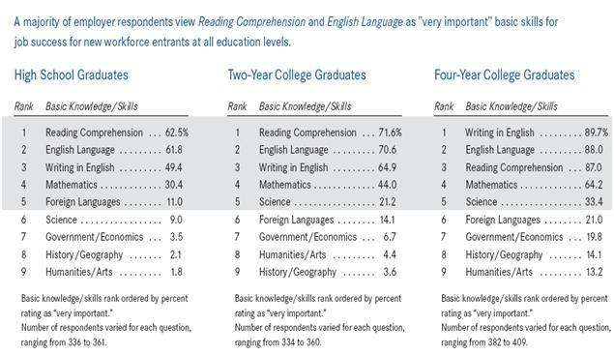

Source : The Conference Board. (2008). Are you Ready to Work?

**Appendix B**

Second Chance Training and Employment Programs Funding Allocation



*Source: Federal programs of Training and Employment, 2009*

**Appendix C**

United States Budget

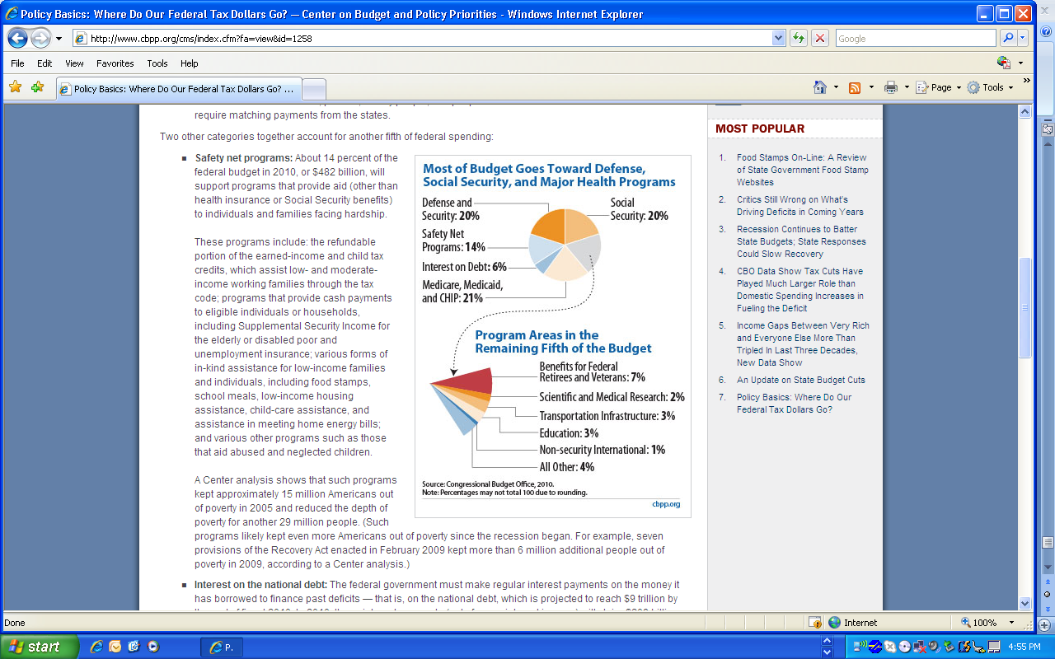

*Source: Center on Budget and Policy Priorities. (2008).*

**Appendix D**

German’s Government expenditure in 2008 by function

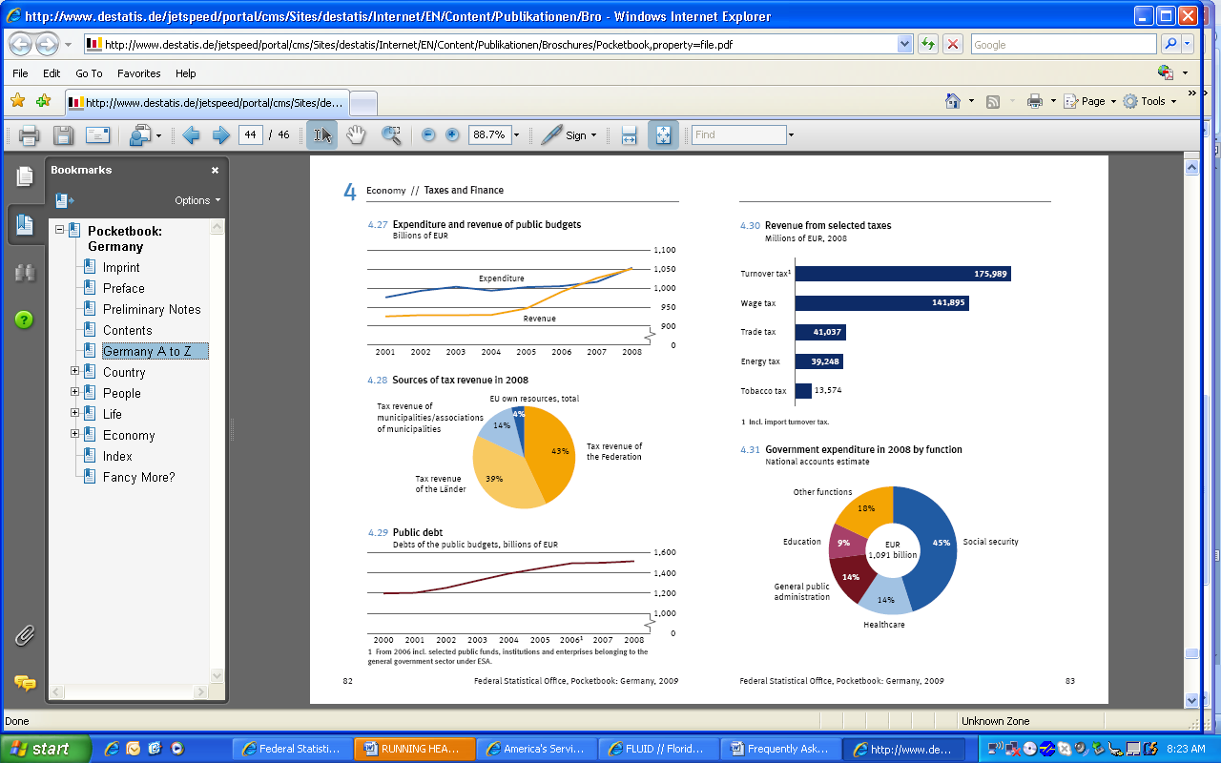

. A skill gap between the work and the worker reduces the competitiveness of American businesses by limiting rates of technical, process, and organizational innovation upon which productivity growth depends. Large numbers of workers with low-skill, as well as low literacy and mathematics levels, also limit the rate at which technologies that increase productivity can be adopted (Eisnen, Jasinowski, & Kleinert, 2005).

1. Data360, 2007
2. United States Department of Labor, 2009
3. United States Department of Labor, 2009.
4. Stasz, C. and Chiesa, J., pg 2
5. MDRC. 2007
6. UNESCO and ILO, pg 3
7. UNESCO, World Conference on Education for All in 1990
8. PISA, 2003, pg. 36
9. The Conference Board, 2009
10. MDRC, 2008
11. MDRC, 2008
12. U.S. Department of Labor, 1999
13. US Census Bureau, 2006
14. National Report System for Adult Education
15. Eric Digest, The GED Testing Program
16. Half of College Students Needing Remediation Drop Out; Remediation Completers Do Almost as Well as Other Students, [Report No. 07-31](http://www.oppaga.state.fl.us/Summary.aspx?reportNum=07-31), May 2007.
17. U.S. Department of Education, Pell Grants
18. Interview, 2009; Central Florida Community College Admissions Office
19. Half of College Students Needing Remediation Drop Out; Remediation Completers Do Almost as Well as Other Students, [Report No. 07-31](http://www.oppaga.state.fl.us/Summary.aspx?reportNum=07-31), May 2007.
20. Federal Statistical Office, Sustainable Development in Germany, Indicator Report 2008
21. Deutscher bildungs server, Adult Education as a second chance.
22. Federal Employment Agency, Bremen Second Chance Education School
23. Federal Employment Agency, Adult School Bremen for second chance education
24. Federal Ministry of Education and Research, Ensuring Equal Opportunities by Means of BAföG
25. Federal Ministry of Education and Research, Ensuring Equal Opportunities by Means of BAföG
26. Federal Employment Agency, 2010
27. Center on Budget and Policy Procedures, 2010 and Federal Statistics Office, 2009