Running head: SECOND CHANCE PROGRAMS

Second Chance Training and Employment Programs

Christina L. Smith

University of South Florida

Dr. McBrien

**Second Chance Training and Employment Programs**

**Abstract**

Second chance training and employment programs are federally funded programs that help individuals who lack a high school diploma, lack basic workplace literacy skills, or lack technical skills for employment or educational purposes. The purpose of this paper analyzed the second chance programs that provide the educational and training where individuals can obtain basic literacy skills, earn a GED, learn new workplace skills and meet the demands of the labor market. The research finds the need to support such programs to help those individuals acquire the skills they need to be self-sufficient. As a result, individuals that are self-sufficient become our most valuable resource to create growth in our economy and advancements globally.

**Second Chance Employment and Training Programs**

**Introduction**

There are two educational systems in the United States today. They are the “first-chance” K-12 system of compulsory education and the “second-chance” system of adult education and training and welfare-to-work programs. The main attendees to the “second-chance” systems are individuals who have not completed the “first chance” K-12 systems as result of individuals dropping out of high school. High School drop outs include those that are economically disadvantaged, pregnant, incarcerated, addicted to drugs, disabled, or just not motivated intrinsically to stay in school. In the United States nearly 31% of students drop out of high school recorded by the Alliance for Excellent Education in 2009. Other attendees to the “second-chance” systems include those that are unemployed adults who have completed high school but are unskilled and unqualified to fill the demand of the jobs in the labor market. Currently unemployment in the United States is at an all time high of 9.7% (US Department of Labor, 2010). The rise in employment started in 2009 when unemployment was recorded at 7.7% in the month of January (US Department of Labor, 2010). The future demands of jobs include biomedical engineers, financial examiners, Medical scientist, physicians that require an advanced degree. The jobs that require additional training without a higher degree include home health aides, physical therapist aides, medical assistants, and dental assistants as referred to in Appendix A (United States Department of Labor, 2009). Each job is unique and the type of job and educational level will depend on each individual’s income level. The term education pays means that a higher level degree pays more than someone that has no high school diploma as referred to in Appendix B (United States Department of Labor, 2010).

The most effective way to create a better-skilled workforce might be to enhance the programs that are more explicitly oriented toward those less educated or those that need to rebuild new skills. “America’s young people will always be struggling to catch up through the second-chance system if the first isn't good enough, and if the first is good enough, the second might not be needed as much” (Stasz, C. and Chiesa, J., pg 2).

**Problem Statement**

Adult education programs have increased with higher standards and new policies. It is not known if there is a direct correlation between the implementation of higher standards and new policies in K-12 public education and adult education that create a more literate adult workforce. In 1991, the Secretary’s Commission on Achieving Necessary Skills in 2001 established workplace skills to help bridge the gap in schools basic literacy skills such as reading, writing, mathematics, listening and speaking (United States Department of Labor, 2001). The gap today, still exist in basic literacy workplace skills. Placing high stakes testing and higher achievement of No Child Left Behind (NCLB) does not automatically fill the workplace literacy skills gap. Action from administrators and educators are needed to assure that teaching practices of workplace literacy skills in K-12 public education are relevant to the workplace and future careers for students.

The Achieve, Inc. (2004) study examines the differences from six states: Florida, Maryland, Massachusetts, New Jersey, Ohio, and Texas. The problem as they define it is that the skills are not aligned with future workplace skills needed for further growth our economy. The study only examined each states exit exams of high school competencies, not actual teaching of workplace literacy’s and competencies. Achieve, Inc. (2004) indicated that 60% of employers say students that graduate lack basic skills in grammar, spelling, writing and basic math and 54% of students in post-secondary school need basic remediation courses. It is indicative that students are unqualified for the workforce and unprepared for post-secondary education. The problem is the gap in school in preparing students for the world of work. It is necessary to examine the second chance training and employment programs that help further understand the gap in preparing individuals to work.

**Background**

Second chance programs are designed to assist an individual with an opportunity to gain or re-gain skills that meet the current workplace demands. The mission is to provide individuals the ability to be self-sufficient in today’s society. The rationale behind second chance programs is that with our changing economy makes it difficult for many people with personal barriers to become employed or even re-employed. These personal barriers can be low basic skills, limited work experience, health problems, disabilities, veteran status, age, unemployed, high school drop outs, released incarcerated youths and limited incomes. These barriers target the young and elderly alike. It generally affects the low income individuals, but can also affect someone who just lost everything in our current economic depression (MDRC, 2007).

“In a time of continuous economic, social and technological change, skills and knowledge become quickly out-of-date. People who have not been able to benefit from formal education and training must be given opportunities to acquire new skills and knowledge that will give them a second chance in life and at work” (UNESCO and ILO, pg 3).

The trend is to increase workforce skills in a competitive global economy by providing second chance training and employment programs.

Second chance programs have been around for a very long time and date as far back as when America was discovered and our founding forefathers and settlers had a second chance at freedom. They discovered that they needed to learn new skills to survive. The education in America was an important concept of surviving then as it is today except the job market is more competitive for individuals to adapt and obtain new skills. As America grew so did the acts of legislative and through the years they have provided many of the “second chance” training and employment programs that we have today. The legislative acts include, but are not limited to the Smith-Fees Act of 1920, the Apprentice Act of 1927, the GED in 1935, the Job Training Partnership Act of 1983, the Americans with Disabilities Act of 1987, the Family Support Act of 1988, the Workforce Investment Act (WIA) of 1998 and the Second Chance Act of 2007. A more detailed list of legislative acts can be reviewed in Appendix C. The legislative acts and many others created second chance programs to promote the ability for individuals to gain the skills to re-enter the workforce and to sustain self efficiency in their community and provide for a more worldwide global economy.

**Purpose**

The purpose of this research will analyze the current federal legislative “second chance” training and employment programs that work for individuals that increase their employability skills either by obtaining a high school diploma or re-learning new skills. The statistics of high school drop outs and unemployment need “second chance” training and employment programs for individuals to be successful and to be a productive viable citizen in a global competitive world.

**Research Question**

1. What are the “second chance” training and employment programs that provide individuals with the qualifications and skills to fill the demands of the labor market?

**Significance**

The United States second chance programs are numerous therefore the significance of this research will be to find the second chance training and employment programs that work. The United States workforce is not prepared for competing in the economy and it is reflected in the studies that have been observed and surveyed for workplace readiness.  In the study done by the Conference Board in 2008 it surveyed businesses that resulted in necessary basic skills, critical thinking skills, ethics, and social training was needed for those entering the workforce. The same skills were recognized as lacking in a *Nation at Risk* when it was written in 1985. Statistics Canada and Organization for Economic Cooperation and Development (OECD) shows data from a study done through the Program for International Student Assessment (PISA).  The PISA is an international assessment of 15 year olds of reading, mathematics, and science literacy.  It is data that is obtained in 2003 from over 42 participating countries.  They define their scope to document that “Literacy skills have a significant impact on economic success” (PISA, 2003, pg. 36). The data for reading literacy skills showed that the United States ranked 16th in the World.  The data for mathematics literacy skills showed that the United States ranked 20th in the World. The data for science literacy skills showed that the United States ranked 15th in the World. The data showed that overall the United States spent three times as much as Canada and Norway in education, but when the United States was compared to Japan, Japan spent three times as much as the United States. The correlation of data that the OECD recorded regarding funding it appears that in the United States was unable to find a direct correlation on the amount of money being spent to the increase in literacy skills. The data is however consistent with one of the reason why we have so many unskilled workers in the United States.

The skills that needed improvement are the same skills needed to sustain a viable and productive workforce. In the study called “Employers’ Perspectives on the Basic Knowledge and Applied Skills of New Entrants to the 21st Century U.S. Workforce”, the Conference Board in 2009 documented that basic skills had improved with additional educational training as referenced in Appendix D. Skills that are important in the United States and the growth of necessary basic workplace literacy skills.

The results in the Center for Law and Social Policy (2008) study stated that businesses felt that education was 75 percent responsible for preparing students for work.  Parents were not included in the survey as being an important part of preparing their child or children to prepare for work.  With that in mind the study from the Center for American Progress (2007) stated that the United States has more than 37 million people live below the poverty level.  It is therefore consistent that poverty contributes to individuals not being prepared for work as families get in the cycle of poverty and stay in poverty (Thinkquest, 2006).

       As employment reaches an all time high most people that want to work are unable to find work. This is an awkward moment in history that will change when baby boomers start to retire.  It is important that now is the time to train and re-train those with new skills for those that are unemployed so that they will be able to fill the position when the positions become available. This will allow filling positions with skilled people in jobs they would not necessarily have filled before training. Therefore, filling the need that second chance training and employment programs should meet that supply before the demand exists.

**Current Trends**

Our educational system has created a problem that does not provide our society with the literacy to have the basic skills for today’s workforce and for today’s technology. Many young students leave schools without the necessary basic literacy or work skills to succeed in the workplace or postsecondary education. “Only 68 out of every 100 ninth graders will complete high school on time” (MDRC, 2008). The only way to increase wages and advance careers will be to acquire the skills necessary to acquire the work and technical skills that qualify them for advancements and higher level of education. “It is emerging as one of the nation’s major challenges in the decades ahead” (MDRC, 2008).

The challenges are spending and the need to increase programs that provide adults a second chance to become self-sufficient. The challenges will be in years ahead, as more people need these programs and the funds for each program are being cut. As a result of poverty, unemployment and the demand for skills workforce increase so will the demand for second chance programs that work supported by less federal funding.

Innovations in technology have created new workplace skills that emphasis more technical, problem-solving skills and competencies that incorporate the use of basic foundational workplace literacy skills. As technology and demographics change our economy requires a new skilled workforce that demands higher skilled workers. If an individual does not have the basic workplace skills of reading, writing and mathematics an individual will be unqualified to work, let alone work in higher skilled paying jobs, leaving them only with low-wage options (U.S. Department of Labor, 1999). The study by Achieve, Inc. (2004) found that 60% of employers say students that graduate lack basic skills in grammar, spelling, writing and basic math. The increased demands of basic workplace literacy skills are necessary for our youth to fill highly skilled jobs.

**Second Chance Training and Employment Programs**

The growth in second chance training and employment programs are derived to close the gap in workplace skills. TheFederal programs that help in such training belong to various divisions that include the Department of Agriculture, Department of Defense, Department of Health and Human Services, Department of Education, Department of Homeland Security, Department of Veterans Affairs, Department of Labor, Corps of Engineers-Civil Works, Office of Personnel Management, Office of Personnel Management, and Railroad Retirement Board. Exportmore.gov presents the data of the many program assessments that have been completed by several Federal agencies, as well as the United States Office of Management and Budget (OMB). The Expectmore.gov website links many of the programs of training and employment and rates them as effective, moderately effective, adequate, and results not demonstrated. Effectiveness is defined as the percentage of participants that completed the program and the amount of participants placed in a job. The following is a list of secondary chance training and employment programs that are known by Expectmore as performing programs.

Adult Education State Grants

American Printing House for the Blind

Assistive Technology Alternative Financing Program

Federal Support for Gallaudet University

Federal Support for the National Technical Institute for the Deaf

Migrant and Seasonal Farm workers

National Institute on Disability and Rehabilitation Research

Supported Employment State Grants

Vocational Rehabilitation Training

Community Services Block Grant

Refugee Social Services

Refugee Transitional and Medical Services

Family Self-Sufficiency Program

Ticket to Work

Temporary Assist26ance for Needy Families

Dislocated Worker National Emergency Grants

Employment Service

Homeless Veterans Reintegration Program

Job Corps

Job Training Apprenticeship

Long shore and Harbor Workers’ Compensation Program

Office of Disability Employment Policy

Pell Grant Program

Prisoner Re-Entry Initiative

Senior Community Service Employment Program

Trade Adjustment Assistance

Veteran’s Employment and Training State Grants

Work Incentive Grants

WIA-Data

WIA-Adult Employment and Training

WIA-Dislocated Worker Assistance

WIA-Migrant and Seasonal Farm workers

WIA-Native American Programs

WIA-Youth Activities

Youthbuild

Vocational Rehabilitation and Employment Program

The list is not limited to the two-hundred and one non-performing programs not listed here but are listed further in detail at Expectmore.gov. For the purpose of this paper the researcher analyzed all performing federal programs to determine the three programs that should provide the most second chance training and employment programs that help those individuals who need the most intervention in closing the gap of obtaining necessary workplace skills. The researcher determined that a closer look into the Adult Education State Grant Programs, Temporary Assistant for Needy Families (TANF), and Unemployment Serviceswould be the programs that would benefit an individual the most if they were economically disadvantaged or unemployed.

*Adult Education State Grants, Department of Education*

The adult education state grants was a direct result of the Adult Education and Family Literacy Act of 1998 with the reform of the new Workforce Investment Act of 1998 regarding Federal employment, adult education, and vocational rehabilitation programs. It created a one-stop center to assist adults and youth nationwide and are administered under the Employment and Training Administration of the United States Department of Labor.

Adult Education State Grants funds state literacy and basic skill programs and is funded by the Department of Labor. Expectmore rates this program as effective. Funds are distributed proportionally to each state to implement such programs that include the GED, Academic Achievement Programs, Civic Engagement Programs, Employment Programs, Older Youth Programs, GED programs and learn English programs. The program of Adult Education State Grant combines the efforts of Department of Education, Office of Vocational and Adult Education, and Division of Academic and Technical Education. In 2002 a new GED series was released and is available in Spanish, French, Braille, audiocassette and large print. The target population includes those that have reached age 16 and older; not enrolled in secondary school; do not have a secondary diploma; lack mastery of basic skills; and are unable to speak, read and write in English. In 2004-2005 the National Reporting System for Adult Education recorded Florida for 1/3 of the participation rate of the least illiterate enrollment. It also recorded that Florida had 13 percent participating at the lowest level of literacy. Data collected by the U.S. Census documented that 26.25 percent of the target population were out of school without a high school diploma (US Census Bureau, 2006).

The GED has become widely available and continues to grow to help individuals meet the educational goals through other programs established by the federal government, helping their programs succeed as well as individuals. Evaluation findings included high school diploma or GED from 2001 to 2007 grew 26 percent (Expectmore.gov, 2010). The program in 2004 found the cost of $3, 081 were the lowest cost per individual as compared to other training programs (Expectmore.gov, 2010). The analysis of the data shows that he assessment recorded by Expectmore evaluated the Adult Education State Grants as excellent.

*Temporary Assistant for Needy Families (TANF), Department of Health and Services*

Temporary Assistant for Needy Families (TANF), Department of Health and Services Florida calls this program Welfare Transition Program; each state has different names under this federally funded program. Purpose of this program is to provide assistance to needy families who have children, reduce dependency of needy parents, prevent out of wedlock pregnancies, encourage two parent families and promote increased work skills. It was created under the Personal Responsibility and Work Opportunity Reconciliation Act of 1996 (PRWORA). Under the direction of the program participants must engage in one of the twelve activities that relate to community service, employment, employment readiness or prepare for work. Certain conditions must be met to receive temporary assistant of food stamps or child care assistant. A five year limitation is place upon participants, but services can be extended under state funding only (U.S. Department of Health and Human Services, 2010). In reviewing data on TANF applications for services there was a substantial change in applications received and approved from 2000 to 2009. The TANF applications received in 2000 were 25, 035 and 11, 141 of those applications were approved to receive benefits as compared to 2009 where 44, 986 applications were received and only 8,137 were approved (U.S Department of Health and Human Services, 2009). Evaluation findings at Expectmore showed work participation rates in the United States at 29.4% and the State of Florida recorded 42.2% among recipients (U.S. Department of Health and Human Services, 2010). The analysis of data shows the reason why the assessment recorded by Expectmore evaluated the Adult Education State Grants as moderately effective.

*Employment Services, Department of Labor*

Employment Service grants provides support of basic employment services and workforce information for job seekers and employers. Services are delivered through a nationwide network of One-Stop Career Centers and Internet-based tools. Services include labor market and career information and job matching. The program focuses on providing a variety of employment related services including but not limited to job search assistance, job referral, and placement assistance for job seekers, re-employment services to unemployment insurance claimants, and recruitment services to employers with job openings. Evaluation findings of data collected from June 2006 to 2007 showed that 63 percent of the 14 million were provided services found job through One-Stop employment and workforce information services. The analysis of the data shows that he assessment recorded by Expectmore evaluated the Employment Services as adequate.

Further analysis of the federal programs assessed allocated the most financial support to Pell Grants within the Department of Education; Temporary Assistant for Needy Families (TANF) within the Department of Health and Services; and Job Corps within the Department of Education, see Appendix E for funding allocation chart of second chance training and employment programs (Expectmore.gov, 2009). Expectmore assessments rated Pell Grants as adequate, Temporary Assistance for Needy Families (TANF) as moderately adequate, and Job Corps as adequate.

***Germany’s Unemployment***

**Conclusion**

In conclusion there is a need for second chance employment and training programs to meet the needs consistently and proportionately with the rise in poverty levels and unemployment rates. Only 3 percent of federal funding is spent on education and combines spending on education, training, employment, social services, secondary education and vocational education (Center on Budget and Policy Procedures, 2010). The minimum amount of money is spent on the education of individuals to become self-sufficient. As a result, individuals that are self-sufficient become our most valuable resource to create growth in our economy and advancements globally.

The individuals that are provided a “first chance’ and “second chance” education creates the social and educational foundation that makes any individual, community or nation succeed. Although there are many barriers that individuals need to overcome the availability of federal programs have the available resources for an individual to overcome many of those barriers. It is up to the individuals’ self-efficacy to overcome those barriers. The researcher believes that from personal experience that the most common problem of receiving notification of training and employment benefits is the lack of communication. Individuals are uninformed about the many programs and resources that are available.

Recommendations would be to increase career and technical education programs and integrate relevant, ready to work skills in the “first chance” K-12 educational system. It is recommended that the Federal government should continue to fund “second chance” programs for those who need those services until most individual obtain the basic literacy skills fully in the “first chance” educational system. It is also recommended that individuals should have more access to the information about each Federal program offered by posting the information in public places such as local schools, libraries, and post offices. As the “first chance” K-12 educational system improves in training individuals it should eliminate an individual’s need for a second chance at obtaining necessary workplace skills and as a result should decrease funding of “second chance” programs.

The final analysis of this research paper requires further research regarding the actual training programs individuals are attending that enhance their workplace skills and increase their educational levels and what skills are they learning?

**References**

Achieve, Inc. (2004). Do graduation tests measure up? A closer look at state high school exit exams. Retrieved March 30, 2009 from <http://www.achieve.org/files/TestGraduation-FinalReport.pdf>

Alliance for Excellent Education. (2009). Understanding high school graduation rates (updated July 2009) Retrieved June 22, 2010, from <http://www.all4ed.org/publication_material/understanding_HSgradrates>

Center on Budget and Policy Priorities. (2010). Policy basics: Where do our federal tax dollars go? Retrieved July 15, 2010 from, <http://www.cbpp.org/cms/index.cfm?fa=view&id=1258>

Center for Educational Research and Innovation. (2003). PISA literacy skills for the World of Tomorrow Further Results from PISA 2000. Retrieved June 2, 2010 from <http://www.pisa.oecd.org/dataoecd/43/9/33690591.pdf>

Center for American Progress. (2007). The poverty epidemic in America, by the numbers. Retrieved July 10, 2010 from, <http://www.americanprogress.org/issues/2007/04/poverty_numbers.html>

The Conference Board. (2009). Are They Really Ready To Work? Retrieved June 12, 2010, from <http://www.p21.org/documents/FINAL_REPORT_PDF09-29-06.pdf>

Thinkquest. (2006). The cycle of poverty. Retrieved June 12, 2010, from <http://library.thinkquest.org/05aug/00282/over_causes.htm>

National Report System for Adult Education. (2006). NRS fast facts. Retrieved July 10, 2010 from <http://www.nrsweb.org/reports/fast_facts.aspx>

MRDC. (2007). Four Strategies to Overcome Barriers to Employment. Retrieved June 15, 2010, from <http://www.mdrc.org/publications/469/overview.html>

MDRC. (2008). Youth Transitions to Work. Retrieved June 2, 2010 from, <http://www.mdrc.org/subarea_index_32.html>

Stasz, C. and Chiesa, J. (1998). Education and the new economy: View from a policy planning. Retrieved June 15, 2010, from <http://www.eric.ed.gov/ERICDocs/data/ericdocs2sql/content_storage_01/0000019b/80/15/74/7f.pdf>

United States Census Bureau. (2006). State Profiles of the Adult Education Target Population. Retrieved July 10, 2010 from, <http://www2.ed.gov/about/offices/list/ovae/pi/AdultEd/census3.pdf>

United States Department of Health and Human Services. (2009). TANF applications. Retrieved July 10, 2010 from, <http://www.acf.hhs.gov/programs/ofa/data-reports/caseload/applications/application.html>

United States Department of Health and Human Services. (2010). Temporary assistance for needy families. Retrieve July 10, 2010 from <http://www.acf.hhs.gov/programs/ofa/particip/2008/tab1a.htm>

United States Department of Health and Human Services. (2010). Office of family assistance. Retrieve July 10, 2010 from <http://www.acf.hhs.gov/opa/fact_sheets/tanf_factsheet.html>

United States Department of Labor. (2010). Education Pays. Retrieved June 27, 2010, from <http://www.bls.gov/emp/ep_chart_001.htm>

United States Department of Labor. (2009). Overview of the 2008-18 Projections. Retrieved June 24, 2010, from <http://www.bls.gov/oco/oco2003.htm#occupation>

United States Department of Labor. (1999). Trends and Challenges for Work in the 21st Century.Retrieved June 19, 2010 from <http://www.dol.gov/oasam/programs/history/herman/reports/futurework/conference/trends/NewTrends_.htm>

United States Department of Labor. (2010). Unemployment rates for states. Retrieved June 18, 2010 from <http://www.bls.gov/web/laus/laumstrk.htm>

United States Department of Labor. (2010). United States Unemployment Rates. Retrieved June 16, 2010, from <http://data.bls.gov/PDQ/servlet/SurveyOutputServlet?series_id=LNS14000000>

U.S. [Office of Management and Budget](http://www.whitehouse.gov/omb/) and Federal agencies. (2010). Programs related to training and employment. Retrieved June 27, 2010 from <http://www.whitehouse.gov/omb/expectmore/topic/Training_and_Employment.html>

UNESCO and ILO. (2002). Technical and Vocational Education Training in the twenty-first century. Retrieved June 15, 2010, from <http://unesdoc.unesco.org/images/0012/001260/126050e.pdf#xml=http://unesdoc.unesco.org/ulis/cgi-bin/ulis.pl?database=ged&set=3D589C86_3_0&hits_rec=1&hits_lng=eng>

Appendices

**Appendix A**

Overview of the 2008-18 Projections, US Department of Labor (2009)

Occupations with the fastest growth

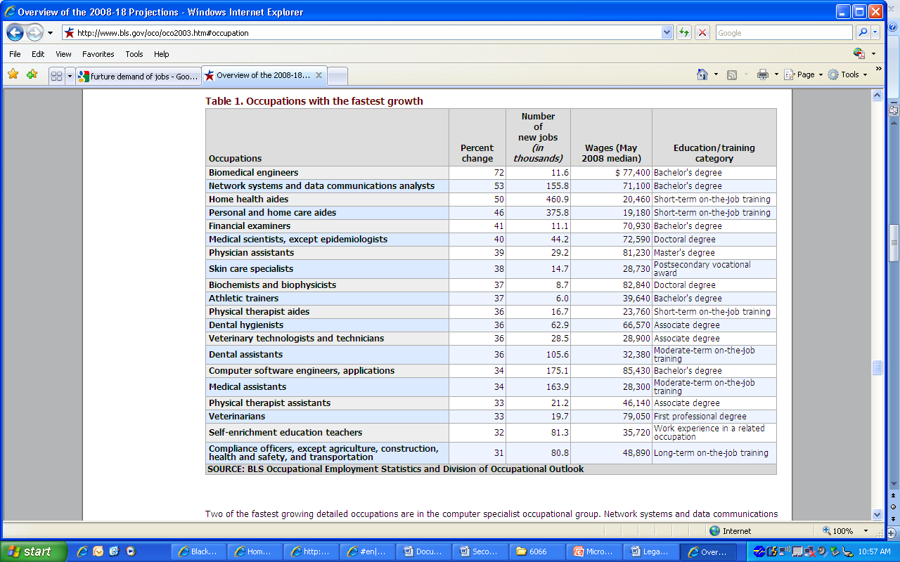

**Appendix B**

Education Pays**,** Bureau of Labor Statistics, 2009

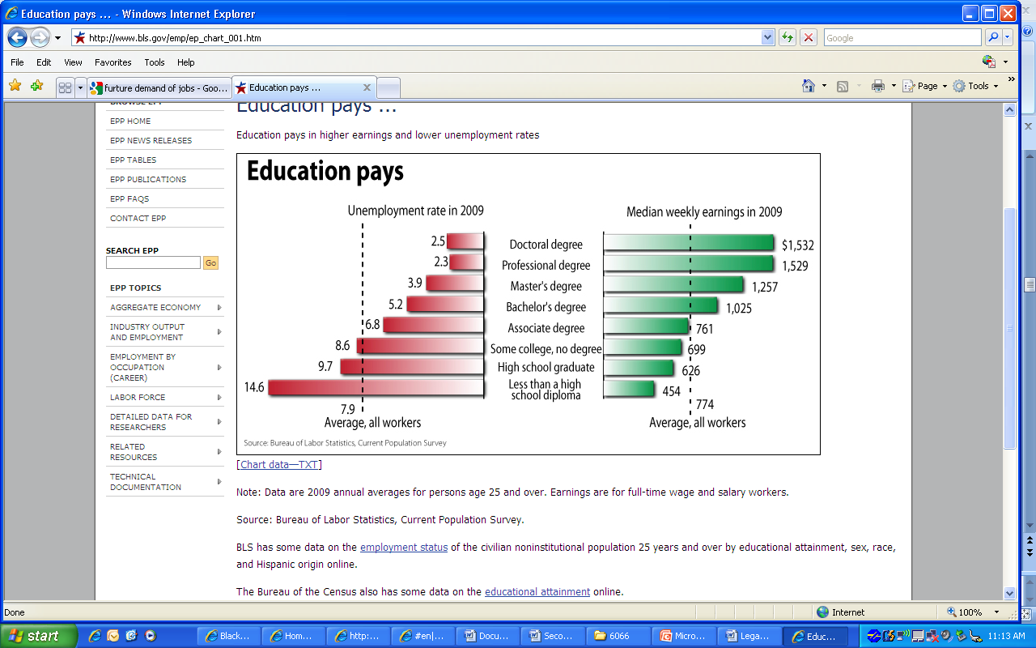

**Appendix C**

Legislative Acts that created second chance training and employment programs

Smith-Fess Act of 1920

Apprentice Act of 1927 *(commonly known as the Fitzgerald Act)*

Wagner-Peyser Act, 1933

Emergency Relief Appropriation Act of 1935 creating the WPA *(Works Progress Administration)*

GED was created in 1935

National Apprentice Act, 1937

The G.I. Bill *(officially titled Servicemen's Readjustment Act)* of 1944

Manpower Development and Training Act of 1962

Civil Rights Act of 1964

Economic Opportunity Act of 1964

Older Americans Act of 1965

Adult Education and Family Literacy Act, 1966

Adult Basic Education Act of 1966, encouraged people to take the GED

The Pell Grant, originally enacted in 1972 as the Basic Educational Opportunity Grant

Rehabilitation Act, 1973

Food Stamp Act of 1977

JTPA-Job Training Partnership Act, 1983

Food Security Act of 1985

Individuals with Disabilities Education Act (IDEA)

Food Security Act of 1985

Stewart B. McKinney Homeless Assistance Act of 1987

Worker Adjustment and Retraining Notification (WARN) Act, 1988

Family Support Act, 1988

The Americans with Disabilities Act of 1990

Americans with Disabilities Act of 1990

The National Literacy Act of 1991

Social Security Act, 1991

Personal Responsibility and Work Opportunity Reconciliation Act, 1996

Workforce Investment Act (WIA), 1998

Adult Education and Family Literacy Act of 1998

Carl D. Perkins Technical and Vocational Education Act, 1998

Ticket to Work and Work Incentive Improvement Act (TWWIIA), 1999

Trade Act of 2002 (1974) or Trade Adjustment Assistance (TAA)

Second Chance Act, 2007

**Appendix D**

Skills obtained through attainment of higher levels of education,

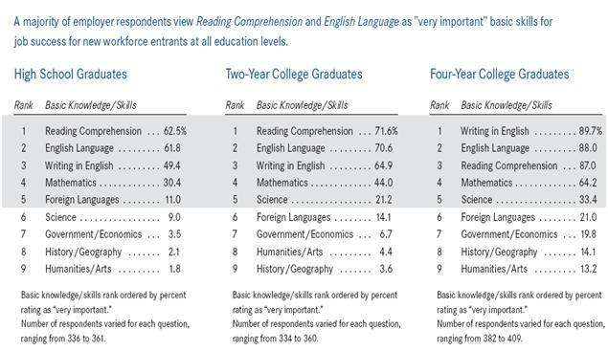

Source : The Conference Board. (2008). Are you Ready to Work?

**Appendix E**

Second Chance Training and Employment Programs Funding Allocation



*Source: Federal programs of Training and Employment, 2009*